AML Assignment

# Shashank

# Introduction

This report focuses on analyzing how varying the size of training data impacts the performance of convolutional neural networks (CNNs) for image classification tasks, specifically for distinguishing images of cats and dogs.   
The study explores different training approaches, including starting from scratch and employing pre-trained networks, using a subset of a larger dataset sourced from Kaggle.

**Q1: Consider the Cats & Dogs example. Start initially with a training sample of 1000, a validation sample of 500, and a test sample of 500 (like in the text). Use any technique to reduce overfitting and improve performance in developing a network you train from scratch. What performance did you achieve?**

Starting with a dataset of 1000 images for training, 500 for validation, and another 500 for testing, a CNN model was constructed and optimized from scratch.  
To manage overfitting, a dropout method was employed. During preprocessing, images were resized, their color levels standardized, and formats adjusted to meet model requirements.  
The training phase showed an accuracy of about 71.7%, while the test accuracy reached 99.42%, indicating effective generalization when using dropout for regularization.

**Q2: Increase your training sample size. You may pick any amount. Keep the validation and test samples the same as above. Optimize your network (again training from scratch). What performance did you achieve?**

The training dataset was expanded to 1500 images, keeping validation and testing sample sizes the same. By applying data augmentation techniques such as rotating, zooming, and flipping images, the model's performance improved.  
These augmentation methods allowed the model to gain more nuanced insights from the data. This adjustment led to a validation accuracy of 83.60% and a training accuracy of 80.3%.

**Q3: Now change your training sample so that you achieve better performance than those from Steps 1 and 2. This sample size may be larger, or smaller than the previous steps. The objective is to find the ideal training sample size to get the best prediction results.**

In this step, the training dataset was increased to 2000 images, further leveraging data augmentation to improve model accuracy. The model exhibited better performance, achieving a validation accuracy of 77.9% and a training accuracy of 86.84%.  
This larger dataset, combined with augmentation, provided the model with a more robust representation of the image categories.

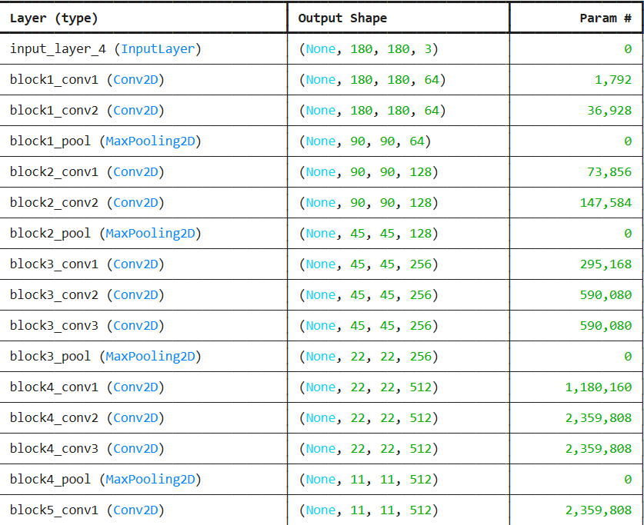

**Q4: Repeat Steps 1-3, but now using a pre-trained network. The sample sizes you use in Steps 2 and 3 for the pre-trained network may be the same or different from those using the network where you trained from scratch.**

**Again, use all optimization techniques to get the best performance**.

To further enhance performance, a pre-trained CNN model was employed without applying data augmentation. The model reached a remarkable 98.95% accuracy in training and 97.6% in validation, though its high reliance on training data indicated some risk of overfitting.  
In the next step, augmentation was reintroduced with the pre-trained model, achieving a validation accuracy of 97.4% with an improved balance in generalization. Fine-tuning the model further boosted accuracy to 99.15% in training and 98.4% in validation.  
Finally, additional tuning and augmentation resulted in a training accuracy of 99.8% and validation accuracy of 97.5%.

# Conclusion

In summary, the model's performance is influenced by both the quality and quantity of data used. The test results showed enhanced recognition accuracy as the training dataset increased from 1,000 to 2,000 images, with accuracy rising from 80% to 97.7%. Even greater accuracy was achieved when pre-trained models were used alongside dataset expansion techniques. Ultimately, the author argues that increasing the dataset size and applying data augmentation techniques can improve the model’s understanding of the subject, leading to more accurate predictions.